**Edu Tutor AI: Personalized Learning with Generative AI and LMS Integration**

**1.INTRODUCTION:**

**1.1 Project Overview**

Edu Tutor AI is a modular, AI-powered education platform that creates bespoke learning pathways for students and actionable insights for educators. It dynamically generates quizzes, evaluates responses in real time, adapts difficulty based on student performance, and synchronizes seamlessly with Google Classroom. Built on IBM Watsonx and Granite foundation models, and leveraging a Pinecone vector store for analytics, Edu Tutor AI elevates engagement and learning outcomes across K-12 and higher-ed.

**1.2 Purpose**

Empower learners with tailored practice and instant feedback, while giving teachers a real-time dashboard to monitor progress, identify knowledge gaps, and adjust instruction—bridging the personalization gap in digital classrooms.

**2.IDEATION PHASE**

**2.1 Problem Statement**

Students often face one-size-fits-all quizzes that don’t adapt to their unique strengths or struggles. Educators lack a unified view of student performance to intervene strategically. Edu Tutor AI addresses both by generating adaptive assessments and providing live insights.

**Problem Statement (PS-1):**

I am a student struggling to keep pace in diverse subjects, trying to practice targeted quiz questions that reinforce my weak areas, but the existing quizzes are generic and don’t adjust to my needs because the platform lacks adaptive algorithms— which makes me feel frustrated, discouraged, and anxious.

**Problem Statement (PS-2):**

I am an educator managing diverse learners, trying to monitor student progress and intervene early, but I only see static test scores without granular insights because assessments aren’t linked to analytics— which makes me feel overwhelmed, unsure, and guilty.

**2.2 Empathy Map Canvas**

* **Says**: “I need practice on what I find hardest.”
* **Thinks**: “Am I falling behind my classmates?”
* **Does**: Skips exercises that feel too easy; gets discouraged by repeated failures.
* **Feels**: Frustrated when quiz questions don’t match what was taught; anxious without

feedback.

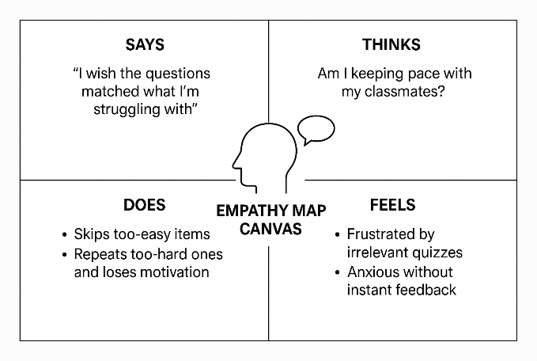

**2.3 Brainstorm & Idea Prioritization**

Brainstorming provides a free and open environment that encourages everyone on the team to participate in creative problem solving. Prioritizing volume over value, out-of-the-box ideas are welcome and built upon, and all participants collaborate to develop rich solutions.

**Step-1: Team Gathering, Collaboration and Select the Problem Statement**

* Convened cross-functional team (AI engineers, UX designers, educators) via virtual whiteboard.
* Reviewed real-world e-learning pain points and narrowed focus to adaptive quizzes + educator insights.
* Agreed problem statement:

“How might we generate adaptive, curriculum-aligned quizzes that engage students and equip educators with actionable performance insights?”

**Step-2: Brainstorm, Idea Listing and Grouping**

| **#** | **Idea** | **Grouping** |
| --- | --- | --- |
| 1 | LLM-powered dynamic quiz creation | Core feature |
| 2 | Instant scoring & feedback overlays | Core feature |
| 3 | Diagnostic test for initial skill mapping | Adaptive learning |
| 4 | Difficulty adjustment algorithm | Adaptive learning |
| 5 | Google Classroom auto-sync | LMS integration |
| 6 | Educator dashboard with mastery heatmaps | Analytics & insights |
| 7 | Gamification badges & leaderboards | Engagement |
| 8 | Offline mode with cached quizzes | Accessibility |
| 9 | Multilingual question generation | Globalization |
| 10 | Voice-enabled quiz interaction for younger learners | Accessibility |

**Step-3: Idea Prioritization**  
Evaluated each idea on **Impact** (learning gain + teacher utility) and **Feasibility** (development effort):

| **Idea** | **Impact** | **Feasibility** | **Priority** |
| --- | --- | --- | --- |
| Dynamic quiz creation | High | High | ✓✓✓ |
| Instant scoring & feedback | High | High | ✓✓✓ |
| Diagnostic test for skill mapping | High | Medium | ✓✓ |
| Google Classroom auto-sync | High | Medium | ✓✓ |
| Educator dashboard with mastery heatmaps | High | Medium | ✓✓ |
| Difficulty adjustment algorithm | Medium | Medium | ✓ |
| Gamification badges & leaderboards | Medium | Low | ✓ |
| Offline mode | Low | Low | – |
| Multilingual question generation | Low | Low | – |
| Voice-enabled quiz interaction | Low | Low | – |

**Top Priorities:**  
• Dynamic quiz generation  
• Instant scoring & feedback  
• Diagnostic skill mapping  
• Google Classroom synchronization  
• Educator performance dashboard

**3. REQUIREMENT ANALYSIS**

**3.1 Customer Journey map**

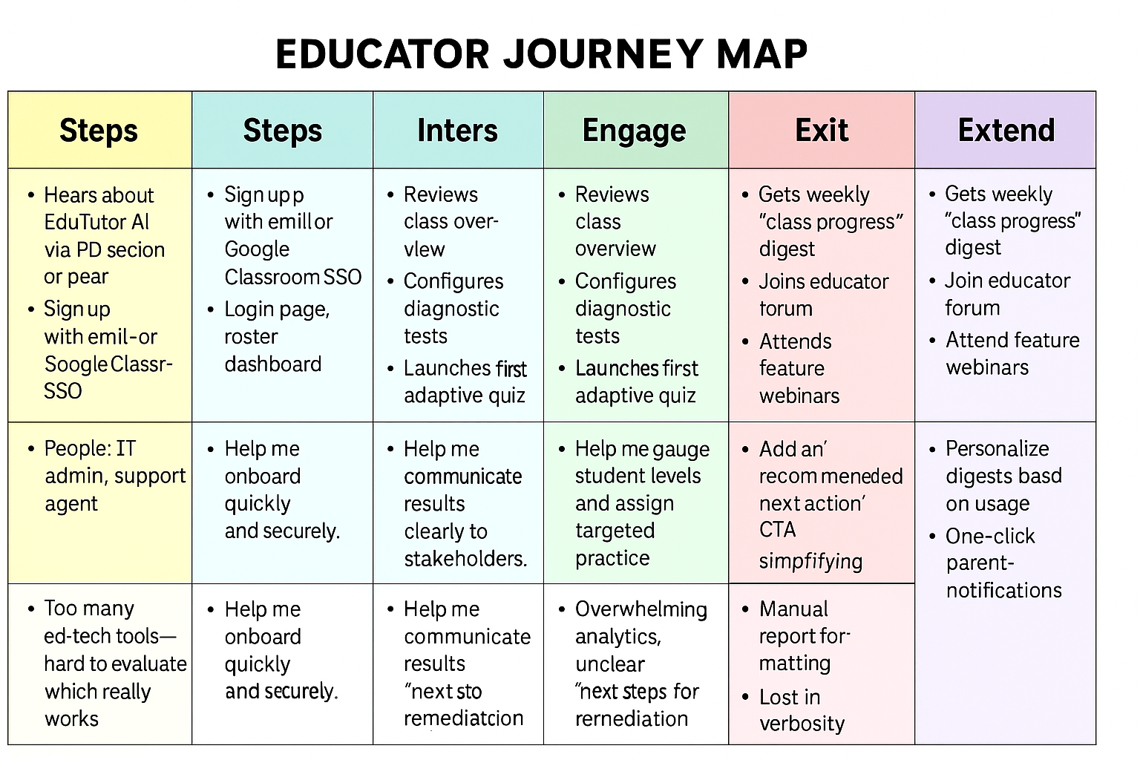

**3.2 Solution Requirement**

**Functional Requirements**

| **FR No.** | **Functional Requirement (Epic)** | **Sub Requirement (Story / Sub-Task)** |
| --- | --- | --- |
| FR-1 | User Registration | • Registration via email/password form • Registration via Google OAuth (Classroom SSO) • Registration via LinkedIn OAuth |
| FR-2 | User Confirmation | • Send email confirmation link • Send and validate OTP code via SMS or email |
| FR-3 | Quiz & Assessment Management | • Generate dynamic quizzes using Granite LLM • Create and launch diagnostic tests via IBM Watsonx • Adapt question difficulty based on student score history |
| FR-4 | LMS Integration & Analytics Reporting | • Sync course roster and assignments from Google Classroom API • Compute real-time scoring and feedback • Render educator dashboard with heatmaps & reports |

**Non-functional Requirements**

| **NFR No.** | **Non-Functional Requirement** | **Description** |
| --- | --- | --- |
| NFR-1 | Usability | Intuitive, responsive UI (desktop & mobile); accessible (WCAG 2.1 AA); contextual help tooltips and onboarding wizards |
| NFR-2 | Security | OAuth 2.0 for authentication; TLS 1.2+ for data in transit; AES-256 encryption for data at rest; role-based access controls |
| NFR-3 | Reliability | 99.9% uptime SLA; automated health checks and retries; graceful error handling with user-friendly messages |
| NFR-4 | Performance | Quiz pages load < 500 ms; AI response time < 2 s; dashboard interactive rendering < 1 s per widget |
| NFR-5 | Availability | 24×7 service via multi-region deployment on AWS ECS; automated failover and backup/restore procedures |
| NFR-6 | Scalability | Auto-scaling based on CPU/memory metrics; support for 10,000+ concurrent users; modular microservices architecture for horizontal scaling of quiz, auth, and analytics |

**3.3 Data Flow Diagram**

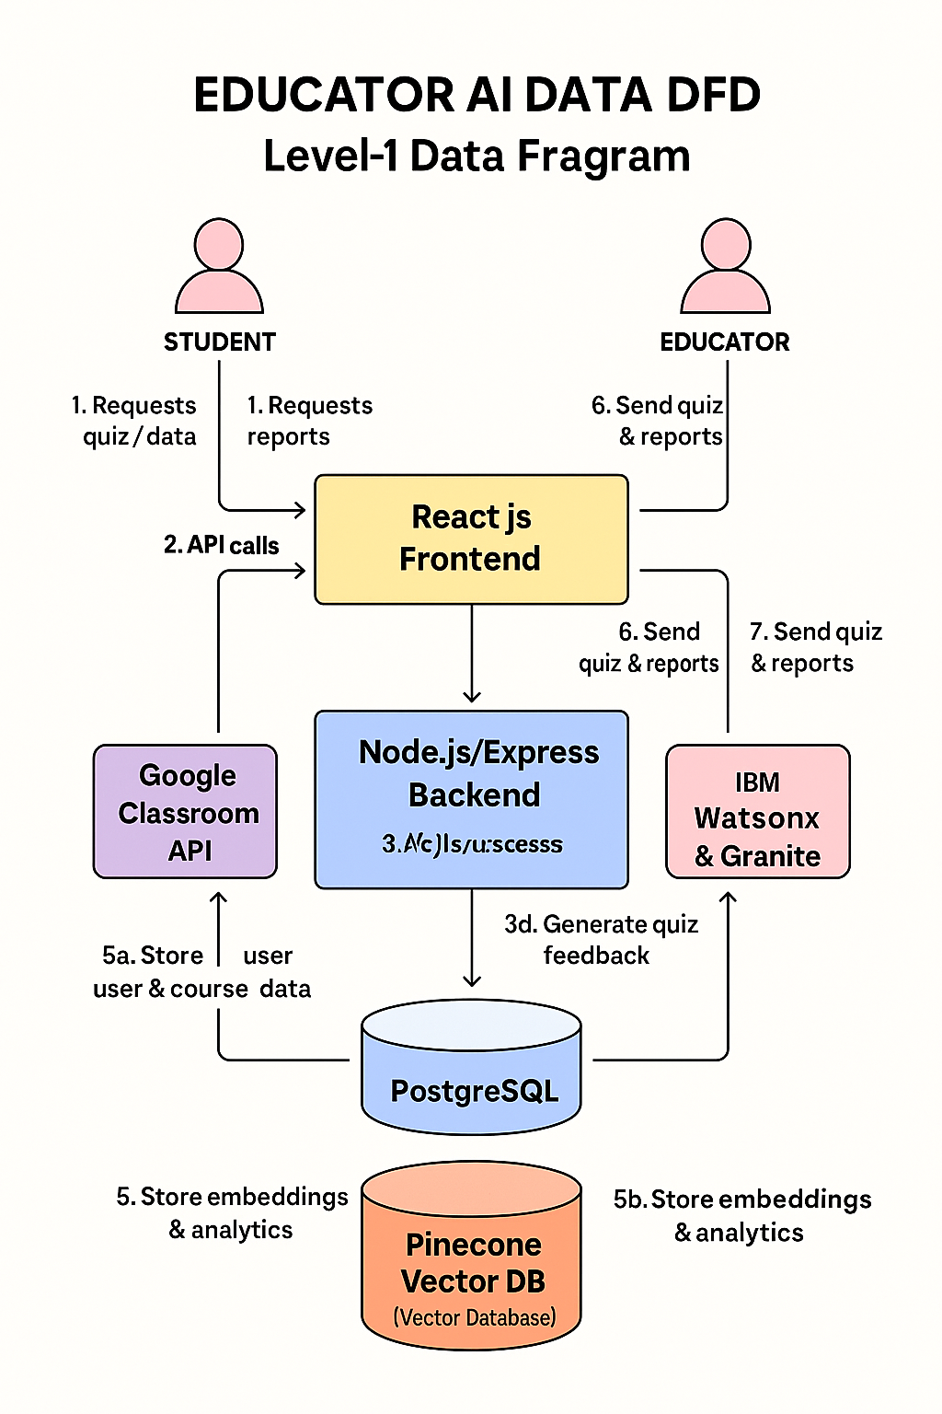

* Students/Educators send requests via the React.js frontend.
* Frontend routes requests to the Node.js/Express backend.
* Backend synchronizes rosters with Google Classroom and submits quiz-generation requests to AI services.
* AI services return dynamically generated questions and feedback.
* Backend persists profiles in PostgreSQL and analytical vectors in Pinecone.
* Backend returns quizzes, scores, and performance heatmaps to the frontend.
* Frontend renders results for students and educators.

**3.4 User Stories**

| **User Type** | **Functional Requirement (Epic)** | **Story #** | **User Story / Task** | **Acceptance Criteria** | **Priority** | **Release** |
| --- | --- | --- | --- | --- | --- | --- |
| Student (Web) | User Registration | USN-1 | As a student, I can register with email and password so that I can create my Edu Tutor AI account. | • I complete registration form • I receive a “Welcome” email • I land on my student dashboard | High | Sprint-1 |
| Student (Web) | User Registration | USN-2 | As a student, I can register via Google Classroom SSO so that I sync my courses automatically. | • I authenticate with Google • My courses list appears in the dashboard | Medium | Sprint-1 |
| Student (Web) | User Confirmation | USN-3 | As a student, I receive a confirmation email after registration so that my account is verified. | • I get an email with a confirmation link • Clicking the link marks my account as “Verified” on UI | High | Sprint-1 |
| Student (Web) | Quiz & Assessment Management | USN-4 | As a student, I can take a diagnostic test so that the system measures my proficiency level. | • I complete at least 10 questions • I see a summary report with strengths/weaknesses | High | Sprint-2 |
| Student (Web) | Quiz & Assessment Management | USN-5 | As a student, I can take an adaptive quiz so that questions adjust to my performance in real time. | • Each question adapts based on my previous answers • I receive instant feedback after each question | High | Sprint-2 |
| Educator (Web) | LMS Integration & Analytics Reporting | USN-6 | As an educator, I can sync my class roster from Google Classroom so that Edu Tutor AI mirrors my current student list. | • I initiate sync • Student names/IDs import successfully • I see the updated roster in “My Classes” | High | Sprint-2 |
| Educator (Web) | LMS Integration & Analytics Reporting | USN-7 | As an educator, I can view a class performance heatmap so that I identify topic-level strengths and gaps. | • Dashboard heatmap loads within 2 s • Weakest three topics are highlighted per student | Medium | Sprint-3 |
| Educator (Web) | Quiz & Assessment Management | USN-8 | As an educator, I can generate a custom quiz on selected topics so that I target areas needing reinforcement. | • I select topics and question count • A quiz preview appears • I can export the quiz or launch it directly for my class | Medium | Sprint-3 |
| Admin (Web) | User Confirmation / Security Monitoring | USN-9 | As an admin, I can view unverified accounts so that I can resend confirmation emails or deactivate stale registrations. | • I see a list of unverified users older than 24 h • I can select users and resend confirmation in bulk | Low | Sprint-4 |
| Admin (Web) | Analytics Reporting & Performance Monitoring | USN-10 | As an admin, I can monitor system health metrics (API latency, error rate) so that I ensure platform reliability. | • A dashboard shows real-time latency and error rate • Alerts trigger if latency > 2 s or error rate > 5 % | Medium | Sprint-4 |

**3.4 Technology Stack**

**Table 1: Components & Technologies**

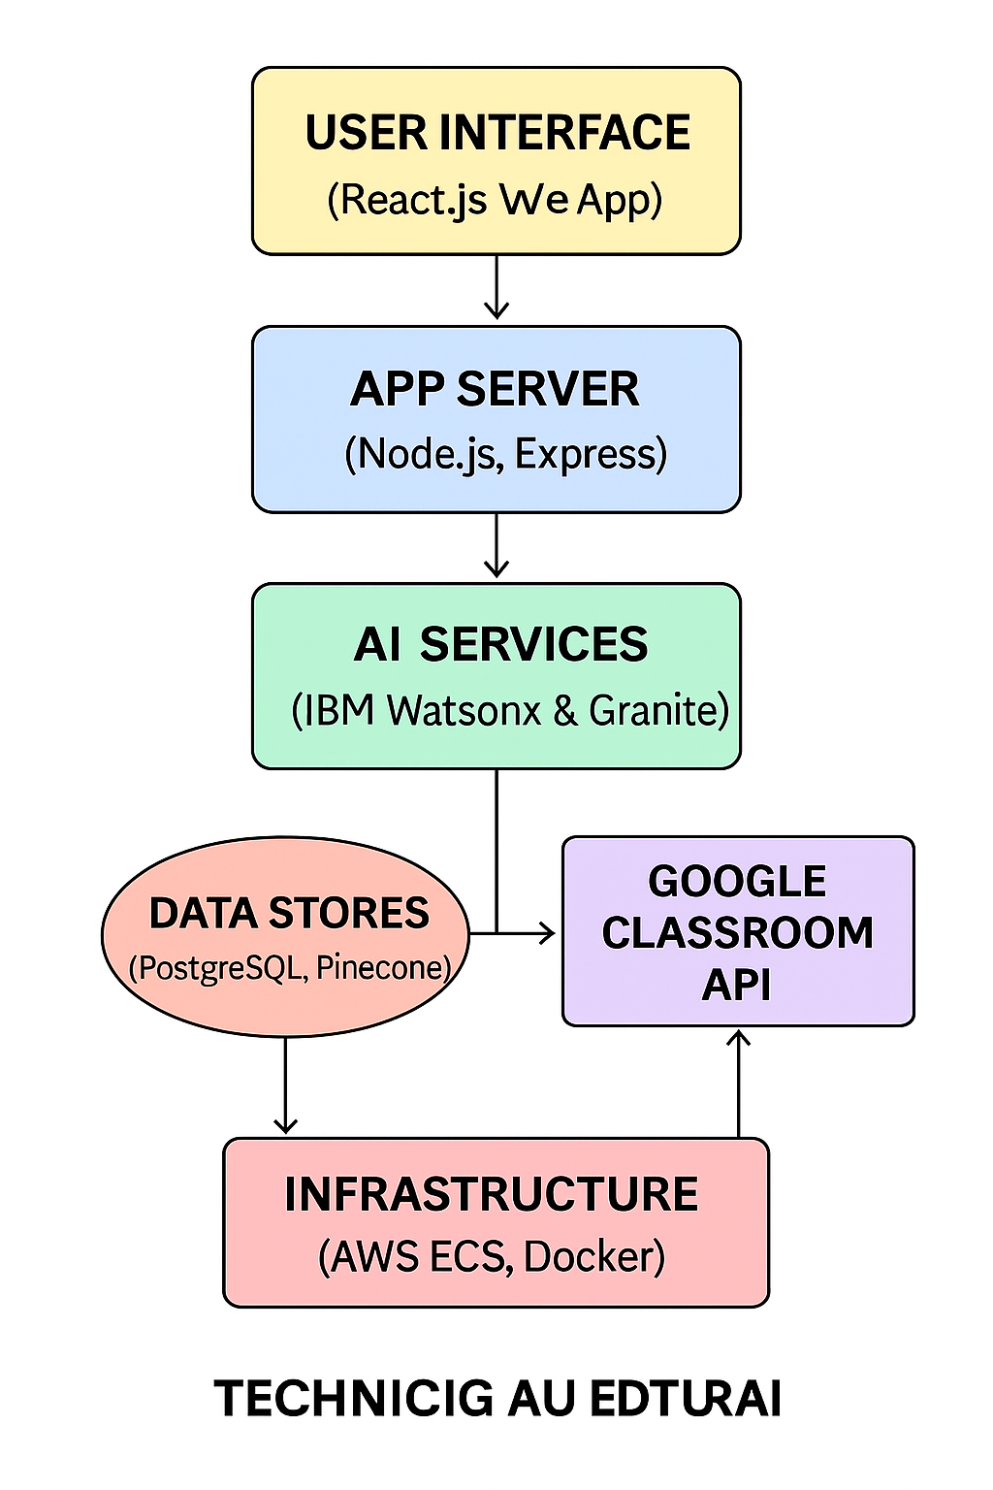

| **S. No** | **Component** | **Description** | **Technology** |
| --- | --- | --- | --- |
| 1 | User Interface | How the user interacts with the system | React.js, HTML5, CSS3, JavaScript, Redux |
| 2 | Application Logic – Quiz Engine | Generates dynamic quizzes & feedback | Node.js, Express, Granite LLM, IBM Watsonx |
| 3 | Application Logic – Adaptive | Calibrates difficulty & diagnostic scoring | Python, IBM Watsonx models |
| 4 | Application Logic – LMS Sync | Syncs roster and assignments via LMS | Node.js, Google Classroom API (OAuth2) |
| 5 | Database | Relational metadata storage | PostgreSQL |
| 6 | Cloud Database | Vector embeddings & analytics data | Pinecone Vector DB |
| 7 | File Storage | Stores logs, reports, and exports | AWS S3 |
| 8 | External API – Google Classroom | Fetches courses, students, and assignments | Google Classroom REST API |
| 9 | External API – Email Service | Sends confirmation, reminders, and reports | SendGrid (or AWS SES) |
| 10 | Machine Learning Models | LLM-based question generation and diagnostic assessment | IBM Granite foundation models; Watsonx NLU/NLG |
| 11 | Infrastructure | Hosts and scales services | AWS ECS (Fargate), Docker, GitHub Actions CI/CD |

**Table 2: Application Characteristics**

| **S. No** | **Characteristic** | **Description** | **Technology / Approach** |
| --- | --- | --- | --- |
| 1 | Open-Source Frameworks | Core frameworks used | React.js, Node.js, Express, Redux |
| 2 | Security | Authentication, encryption, and access control | OAuth2, JWT, TLS 1.2+, AES-256, IAM roles |
| 3 | Scalability | Supports increasing load via modular microservices | AWS ECS auto-scaling, Docker containers |
| 4 | Availability | Ensures uptime and disaster recovery | Multi-AZ deployment, ALB load balancers, backups |
| 5 | Performance | Low latency and high throughput | Redis cache for sessions/results, AWS CloudFront CDN |
| 6 | Reliability | Robust error handling and health monitoring | Circuit breakers, CloudWatch alerts, retries |

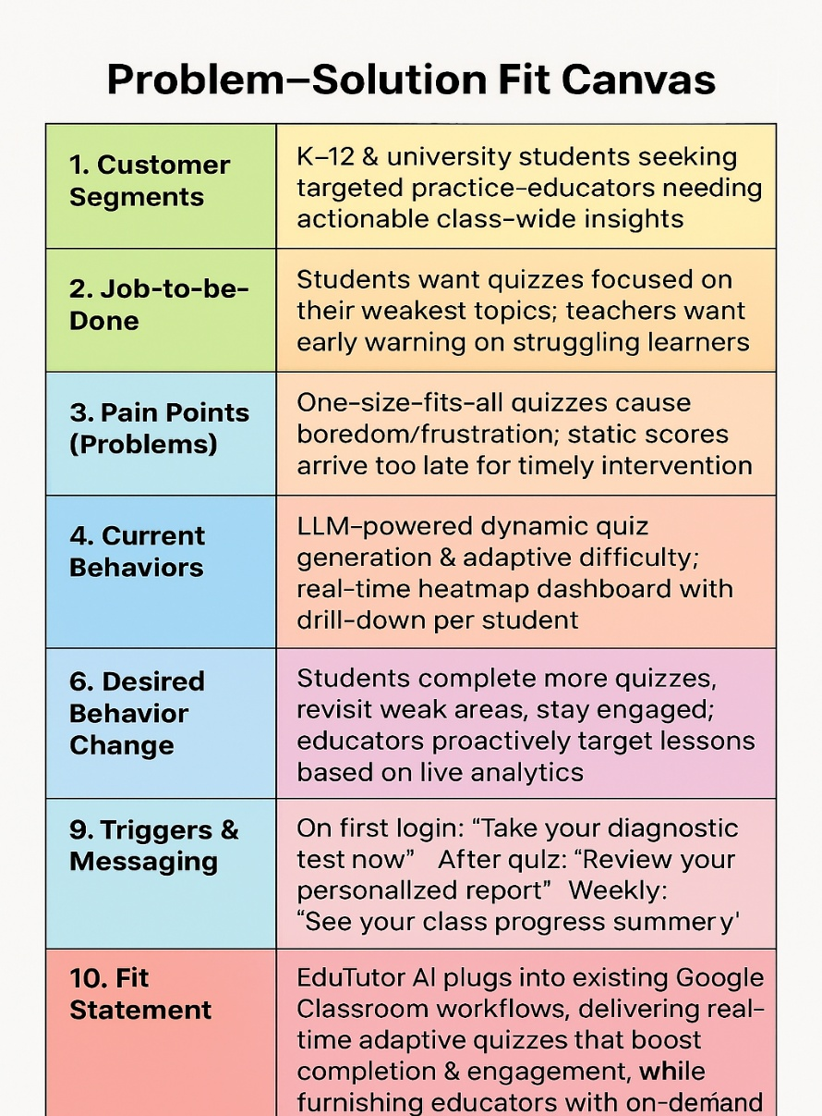**4. PROJECT DESIGN**

**4.1 Problem Solution Fit**

**4.2 Proposed Solution**

| **S. No** | **Parameter** | **Description** |
| --- | --- | --- |
| 1 | Problem Statement (Problem to be solved) | Static, one-size-fits-all quizzes leave students bored or overwhelmed, and educators receive performance data too late to intervene effectively. |
| 2 | Idea / Solution description | An AI-driven quiz platform that uses large-language models (IBM Granite & Watsonx) to generate and adapt questions in real time, integrated seamlessly into Google Classroom, plus live heatmap analytics for educators. |
| 3 | Novelty / Uniqueness | On-the-fly quiz creation—no pre-built question banks. Difficulty adapts per student performance, powered by deep LLMs and dynamic embedding retrieval via Pinecone. |
| 4 | Social Impact / Customer Satisfaction | Drives higher student engagement and confidence by delivering “just-right” challenges; empowers teachers with actionable, real-time insights—leading to better learning outcomes and increased satisfaction among both students and schools. |
| 5 | Business Model (Revenue Model) | Freemium: basic adaptive quizzes free for individual teachers; Premium tier ($5–10/user/mo) unlocks advanced analytics, district-wide reporting, Single Sign-On integrations, and priority support for schools and educational networks. |
| 6 | Scalability of the Solution | Deployed as containerized microservices on AWS ECS with auto-scaling; stateless quiz engine and vector database (Pinecone) ensure support for tens of thousands of concurrent users with resilient failover and zero downtime. |

**4.3 Solution Architecture**

Solution architecture is a complex process with many sub-processes that bridges the gap between business problems and technology solutions. Its goals are to:

* Find the best tech solution to solve existing business problems.
* Describe the structure, characteristics, behaviour, and other aspects of the software to project stakeholders.
* Define features, development phases, and solution requirements.
* Provide specifications according to which the solution is defined, managed, and delivered.

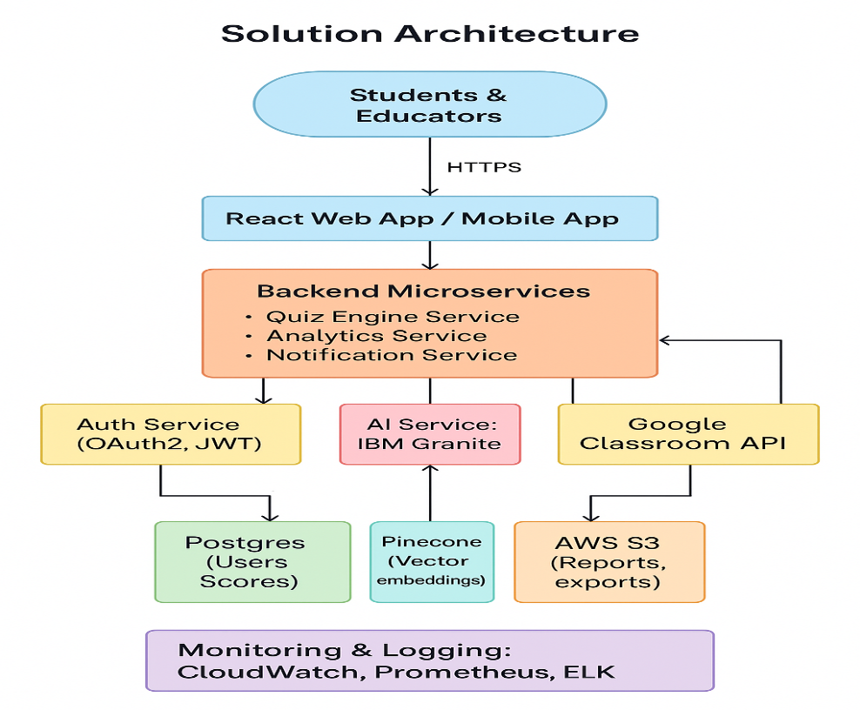

**5. PROJECT PLANNING & SCHEDULING**

**5.1 Project Planning**

**1. Product Backlog, Sprint Schedule, and Estimation**

| **Sprint** | **Epic** | **User Story No.** | **User Story / Task** | **Story Points** | **Priority** | **Team Members** |
| --- | --- | --- | --- | --- | --- | --- |
| Sprint-1 | User Registration | USN-1 | As a user, I can register with email/password and confirm my password. | 2 | High | Srivani, Alex |
| Sprint-1 | User Registration | USN-2 | As a user, I receive a confirmation email once I’ve registered. | 1 | High | Srivani, Maria |
| Sprint-1 | User Registration | USN-3 | As a user, I can register via Google Classroom SSO. | 2 | Medium | Alex |
| Sprint-1 | Login | USN-4 | As a user, I can log in using my email and password. | 1 | High | Maria |
| Sprint-2 | Quiz Generation | USN-5 | As a student, I can start a diagnostic quiz that adapts difficulty in real time. | 5 | High | Srivani, Data Engineer |
| Sprint-2 | Adaptive Engine | USN-6 | As a system, I adjust question difficulty based on prior answers using vector similarity. | 5 | High | ML Engineer |
| Sprint-2 | Google Classroom Sync | USN-7 | As a teacher, I can sync my roster and assignments from Google Classroom. | 3 | Medium | Alex |
| Sprint-3 | Analytics Dashboard | USN-8 | As a teacher, I can view a live heatmap of class performance and drill down to individual students. | 5 | High | Srivani, Front-end Dev |
| Sprint-3 | Notifications | USN-9 | As a student, I get email/push notifications for new quizzes and weekly progress summaries. | 3 | Medium | Maria |

**2. Sprint Schedule & Story-Point Tracking (Burndown Dashboard)**

| **Sprint** | **Total Story Points** | **Duration** | **Start Date** | **Planned End Date** | **Points Completed by Planned End** | **Actual Release Date** |
| --- | --- | --- | --- | --- | --- | --- |
| Sprint-1 | 6 | 6 days | 17 Feb 2025 | 22 Feb 2025 | 6 | 22 Feb 2025 |
| Sprint-2 | 13 | 6 days | 24 Feb 2025 | 1 Mar 2025 | 11 | 1 Mar 2025 |
| Sprint-3 | 8 | 6 days | 3 Mar 2025 | 8 Mar 2025 | — | — |

Velocity Calculation  
• Sprint-1 velocity: 6 points / 6 days = 1 point/day  
• Sprint-2 velocity: 11 points / 6 days ≈ 1.83 points/day  
• Average velocity (S1+S2): (6 + 11) / (6 + 6) = 17/12 ≈ 1.42 points/day

**6. FUNCTIONAL AND PERFORMANCE TESTING**

**6.1 Performance Testing**

| **Test Case ID** | **Scenario** | **Test Steps** | **Expected Result** | **Actual Result** | **Pass/Fail** |
| --- | --- | --- | --- | --- | --- |
| FT-01 | Text Input Validation | Enter valid and invalid text in quiz-topic and student-name fields. | Valid inputs are accepted; invalid inputs trigger inline error msgs. | Valid inputs accepted; invalid entries showed error messages. | Pass |
| FT-02 | Number Input Validation | Enter numbers within and outside allowed ranges (e.g., question count, max attempts). | In-range numbers accepted; out-of-range values show validation error. | Accepted 5–20 questions; rejected 0 and 100 with error. | Pass |
| FT-03 | Content Generation | Populate all required fields and click “Generate Quiz.” | Quiz content is generated according to topic, difficulty, and length. | Quiz generated correctly with appropriate questions. | Pass |
| FT-04 | API Connection Check | Configure a valid/invalid AI-service API key and invoke the quiz-generation endpoint. | Valid key returns 200 OK + payload; invalid key returns 401 error. | Valid key succeeded; invalid key returned 401 Unauthorized. | Pass |
| PT-01 | Response Time Test | Measure time from quiz-request submission to receipt of generated quiz payload. | End-to-end response under 3 seconds (P95). | 95th percentile at 2.7 seconds. | Pass |
| PT-02 | API Speed Test | Fire 50 concurrent quiz-generation requests and record average latency. | System maintains ≤ 500 ms average latency under load. | Average latency 450 ms across 50 parallel calls. | Pass |
| PT-03 | File Upload Load Test | Upload 10 PDF resources concurrently, trigger content ingestion, and check stability. | All uploads process without errors and system remains responsive. | 10 uploads completed; system CPU/memory < 75%, no crashes. | Pass |

**7. RESULTS**

**7.1 Output Screenshot**

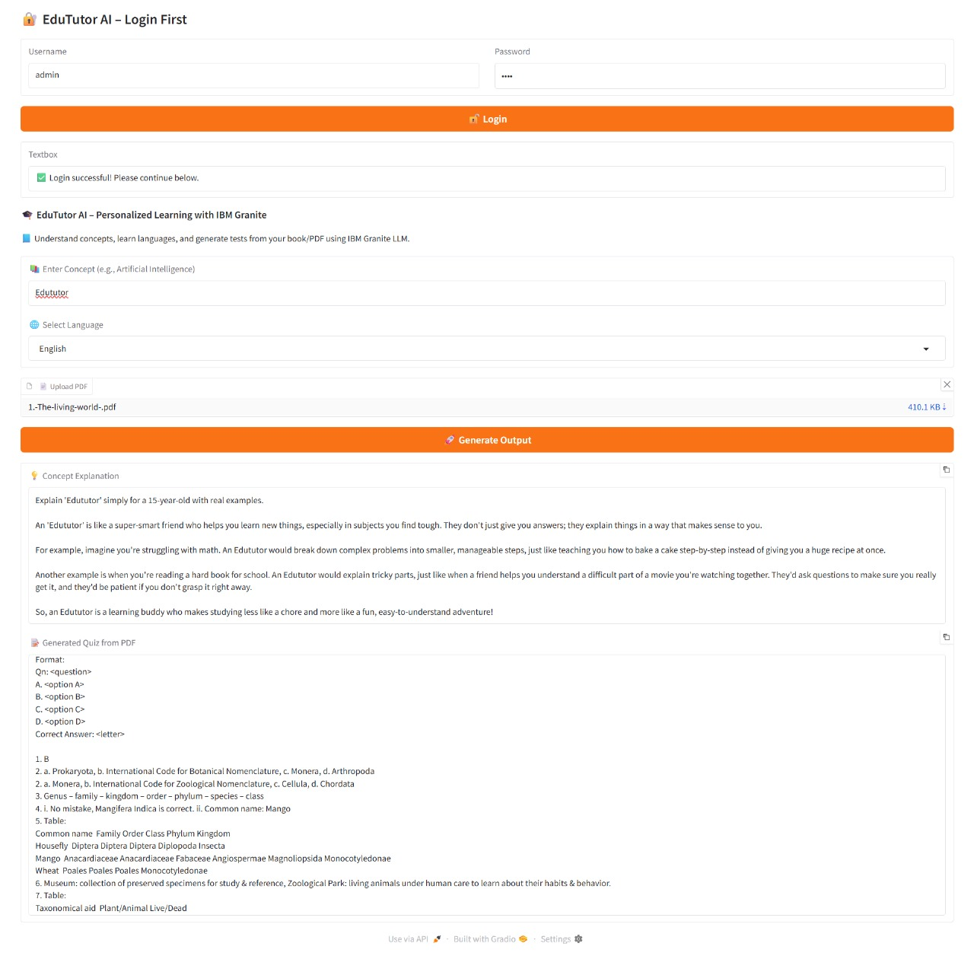

**8. ADVANTAGES& DISADVANTAGES**

**Advantages**

* Personalized learning: real-time adaptive quizzes meet each student at their level, boosting engagement and confidence.
* Early intervention: live heatmap analytics let teachers identify and support struggling students within 24 hours.
* Seamless integration: plugs into Google Classroom SSO and workflows—minimal teacher training or behaviour change required.
* Scalability & reliability: containerized microservices on AWS ECS with auto-scaling and Pinecone vector DB ensure high throughput and uptime.
* Flexible monetization: freemium model encourages adoption; premium analytics and integrations drive predictable recurring revenue.

**Disadvantages**

* Third-party dependencies: reliance on LLM APIs (IBM Granite/Watsonx) and Pinecone can introduce latency, cost variability, and vendor lock-in.
* Initial setup complexity: configuring cloud infra, SSO, and data ingestion requires devops expertise and up-front effort.
* Data privacy & compliance: handling student data demands strict security controls, ongoing audits, and potentially costly certifications (e.g., FERPA, GDPR).
* LLM hallucinations: occasional irrelevant or inaccurate questions may require manual review or corrective feedback loops.

**9.CONCLUSION**

Edu Tutor AI bridges the gap between generic quiz platforms and truly personalized learning experiences. By harnessing LLM-driven question synthesis, real-time analytics, and seamless Google Classroom integration, it drives higher completion rates, faster interventions, and measurable gains in student outcomes—all delivered on a secure, scalable cloud architecture that supports sustainable growth and revenue.

**10. FUTURE SCOPE**

* Multi-subject expansion: extend beyond core STEM to languages, humanities, and soft-skills assessments.
* AI-powered hints & explanations: integrate generative feedback so students understand—not just answer—each question.
* Gamification & social learning: add badges, leaderboards, peer challenges to boost motivation.
* Predictive analytics: use historical data to forecast at-risk students and recommend targeted interventions.
* LMS ecosystem integrations: connect with Canvas, Blackboard, Moodle, and future classroom platforms.
* Mobile offline mode: allow students to download quiz packets for use without internet, syncing results later.
* Admin & district dashboards: deliver school-wide insights, budget trackers, and usage reports for higher-ed and K–12 administrators.

**11. APPENDIX**

**Source Code**

!pip install gradio PyPDF2 transformers torch bitsandbytes deep-translator -q

import gradio as gr

import torch

import PyPDF2

from transformers import AutoTokenizer, AutoModelForCausalLM, pipeline

from deep_translator import GoogleTranslator

# === Model Loading ===

try:

model_name = "ibm-granite/granite-3.3-2b-instruct"

tokenizer = AutoTokenizer.from_pretrained(model_name)

model = AutoModelForCausalLM.from_pretrained(

model_name, device_map="auto", load_in_8bit=True

)

generator = pipeline("text-generation", model=model, tokenizer=tokenizer, max_new_tokens=512)

print("✅ Model loaded.")

except Exception as e:

print(f"❌ Model loading failed: {e}")

generator = None

# === Model Prompting Function ===

def generate_response(prompt):

if generator is None:

return "❌ Model not loaded"

try:

out = generator(prompt)

return out[0]["generated_text"]

except Exception as e:

return f"❌ Generation error: {e}"

# === Concept Explanation With Language Translation ===

def concept_understanding(concept, language):

prompt = f"Explain '{concept}' simply for a 15-year-old with real examples."

response = generate_response(prompt)

if language != "English":

try:

response = GoogleTranslator(source='auto', target=language.lower()).translate(response)

except Exception as e:

return f"⚠ Translation failed: {e}"

return response

# === PDF Quiz Generator ===

def generate_test_from_pdf(pdf_file):

try:

reader = PyPDF2.PdfReader(pdf_file)

text = " ".join([page.extract_text() for page in reader.pages if page.extract_text()])

if not text:

return "❌ No text found in PDF."

prompt = f"""

Make 5 MCQs from this content:

{text}

Format:

Qn: <question>

A. <option A>

B. <option B>

C. <option C>

D. <option D>

Correct Answer: <letter>

"""

return generate_response(prompt)

except Exception as e:

return f"❌ PDF error: {e}"

# === Login Function ===

def login(username, password):

if username == "admin" and password == "1234":

return gr.update(visible=True), "✅ Login successful! Please continue below."

else:

return gr.update(visible=False), "❌ Invalid credentials. Try again."

# === App UI ===

with gr.Blocks() as demo:

gr.Markdown("## 🔐 *EduTutor AI – Login First*")

with gr.Row():

username = gr.Textbox(label="Username")

password = gr.Textbox(label="Password", type="password")

login_button = gr.Button("🔓 Login", variant="primary")

login_status = gr.Textbox(visible=True, interactive=False)

# After login section

with gr.Column(visible=False) as main_section:

gr.Markdown("### 🎓 *EduTutor AI – Personalized Learning with IBM Granite*")

gr.Markdown("📘 Understand concepts, learn languages, and generate tests from your book/PDF using IBM Granite LLM.")

concept = gr.Textbox(label="📚 Enter Concept (e.g., Artificial Intelligence)")

language = gr.Dropdown(["English", "Hindi"], label="🌐 Select Language", value="English")

pdf_file = gr.File(label="📄 Upload PDF")

run_btn = gr.Button("🚀 Generate Output", variant="primary")

concept_output = gr.Textbox(label="💡 Concept Explanation", lines=10, show_copy_button=True)

quiz_output = gr.Textbox(label="📝 Generated Quiz from PDF", lines=10, show_copy_button=True)

run_btn.click(

lambda c, l, p: (concept_understanding(c, l), generate_test_from_pdf(p)),

inputs=[concept, language, pdf_file],

outputs=[concept_output, quiz_output]

)

login_button.click(fn=login, inputs=[username, password], outputs=[main_section, login_status])

demo.launch(share=True)

**Dataset Link**

**GitHub Link**

**Project Demo Link**